ANSWERBOT – AI-POWERED FAQ AND CUSTOMER SUPPORT AUTOMATION

1. Introduction
AnswerBot is an AI-powered FAQ and customer support automation system designed to help users find answers to frequently asked questions and help content creators prepare and manage FAQ records.

2. Abstract
AnswerBot uses Node.js and Express.js for the backend, MongoDB and Mongoose for data storage and validation, JWT authentication and bcrypt password hashing for account protection, and Google Gemini AI for FAQ question-and-answer generation. The system supports FAQ categorization, search, and CRUD operations through RESTful APIs.

3. Project Overview
AnswerBot provides a centralized backend for FAQ content management and AI-assisted content generation. Public users can view and search published FAQ content, while authenticated creators can create and manage their own records.

4. Problem Statement
- Preparing and maintaining FAQ documentation manually is time-consuming.
- Repeated customer questions increase the workload of support teams.
- Organizing questions by topic and category can be difficult.
- Users may have difficulty finding relevant answers through basic browsing.
- Private FAQ records require access controls to prevent unauthorized modification.

5. Objectives
- Provide a centralized platform for FAQ creation, storage, and retrieval.
- Generate FAQ questions and answers with Google Gemini AI assistance.
- Allow keyword-based FAQ search and category-wise organization.
- Protect user accounts and private operations using authentication and authorization.
- Maintain data integrity through Mongoose schema validation and centralized error handling.

6. Scope of the Project
The project focuses on backend REST API functionality including user registration and login, FAQ CRUD operations, category assignment, search, AI-assisted FAQ generation, and role-based access concepts. API requests and responses can be tested using Postman or Thunder Client. A separate frontend interface is not specified in the supplied project reference.

7. Existing System and Proposed System
Existing System | Proposed System
Manual FAQ drafting, categorization, updating and searching with limited automation. | Centralized FAQ management using MongoDB and Express.js REST APIs.
Higher effort for repeated content preparation. | AI-assisted FAQ drafting using Google Gemini.
Difficult maintenance and organization. | Category-based organization, search and CRUD operations.

8. Technologies and Requirements
Type | Requirement
OS | Windows 10/11, macOS, or Linux
Runtime | Node.js v18 or above
Package Manager | npm v9 or above
Backend | Express.js v4/v5 ecosystem
Database | MongoDB / Mongoose ODM
API Testing | Postman / Thunder Client
Code Editor | Visual Studio Code
Hardware | Intel Core i5 8th Gen / AMD Ryzen 5 or equivalent; 8 GB RAM minimum; 1 GB storage

9. System Architecture
- API Interface: Postman or Thunder Client sends HTTP requests and receives JSON responses.
- Express Server: Accepts requests, maps routes, parses JSON and configures CORS.
- Authentication Middleware: Reads and verifies JWT tokens for protected endpoints.
- Routes and Controllers: Direct requests to application logic and prepare responses.
- Models and Database Layer: Mongoose schemas validate and interact with MongoDB collections.
- AI Service Integration: Google Gemini SDK supports FAQ generation and AI-assisted workflows.

10. Database / ER Description
Entity | Main Fields
User | _id, name, email, password (hashed), role, createdAt, updatedAt
FAQ | _id, question, answer, category, createdBy, createdAt, updatedAt
AI Generation (Logical) | topic, generatedQuestion, generatedAnswer, generatedCategory, generatedAt
Category (Logical) | categoryName, description, totalFAQs

11. Key Features
- JWT Authentication & Authorization
- AI FAQ Generation using Google Gemini
- Keyword-based FAQ Search
- FAQ Create, Read, Update and Delete operations
- Category Management
- bcrypt Password Hashing
- Centralized Error Handling
- Mongoose Schema Validation
- RESTful API Architecture
- MongoDB Integration

12. Roles and Responsibilities
Role | Responsibilities
Admin | Manage users, FAQs, AI-generated content and categories; access complete system functionality.
Content Creator | Create, edit and delete owned FAQs; generate FAQs using AI; organize content by category.
Authenticated User | View/search public FAQs, generate AI-assisted answers and access personal profile information.
Public User | View/search published FAQs; cannot access protected operations.

13. Project Setup and Configuration
- Create a new project folder.
- Create a src folder inside the project folder and open the project in VS Code.
- Initialize the Node.js project with npm init -y.
- Install the documented dependencies: express, mongoose, dotenv, cors, jsonwebtoken, bcrypt and @google/genai.
- Configure the required environment variables for the application and database.
- Start the backend using npm run dev.
- Use Postman or Thunder Client to test the API endpoints.

14. Project Structure
The documented backend structure includes server/app setup, authentication middleware, error middleware, Mongoose models, route modules and AI operations under the src directory.

15. API Testing / Execution
Operation | Route | Access
Register | POST /api/auth/register | Public
Login | POST /api/auth/login | Public
Create FAQ | POST /api/faqs | Private – Bearer JWT
FAQ Search | PUT /api/faqs/search?q=technology | Public
AI Generate FAQ | POST /api/ai/generate-faq | Private – Bearer JWT

16. Sample API Payloads
Registration:
{"name":"Priya Sharma","email":"priya@writeflow.com","password":"securepassword123"}
Login:
{"email":"priya@writeflow.com","password":"securepassword123"}
Create FAQ:
{"question":"what is node.js","answer":"node.js is a run time environment build on chromes v8 engine.","category":"Technology"}
AI FAQ Generation:
{"topic":"Express.js"}

17. Project Execution – Screenshots
Insert the corresponding screenshots from the project execution section here:
- REGISTRATION API RESPONSE – POSTMAN / THUNDER CLIENT

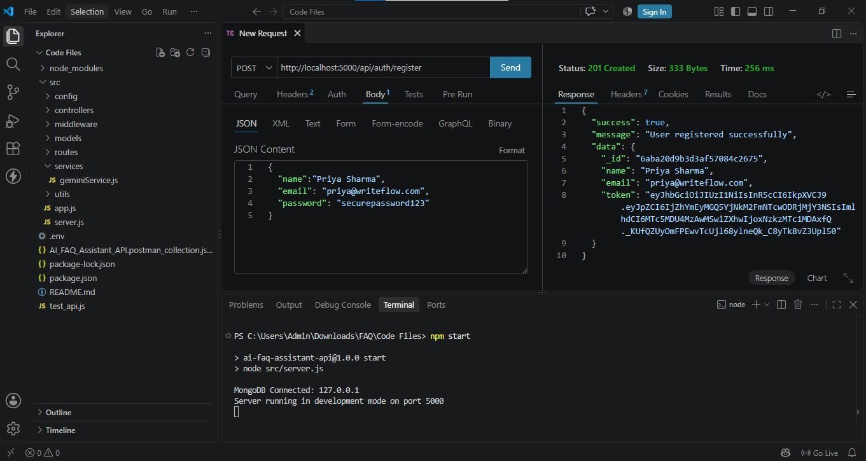

- LOGIN API RESPONSE – POSTMAN / THUNDER CLIENT
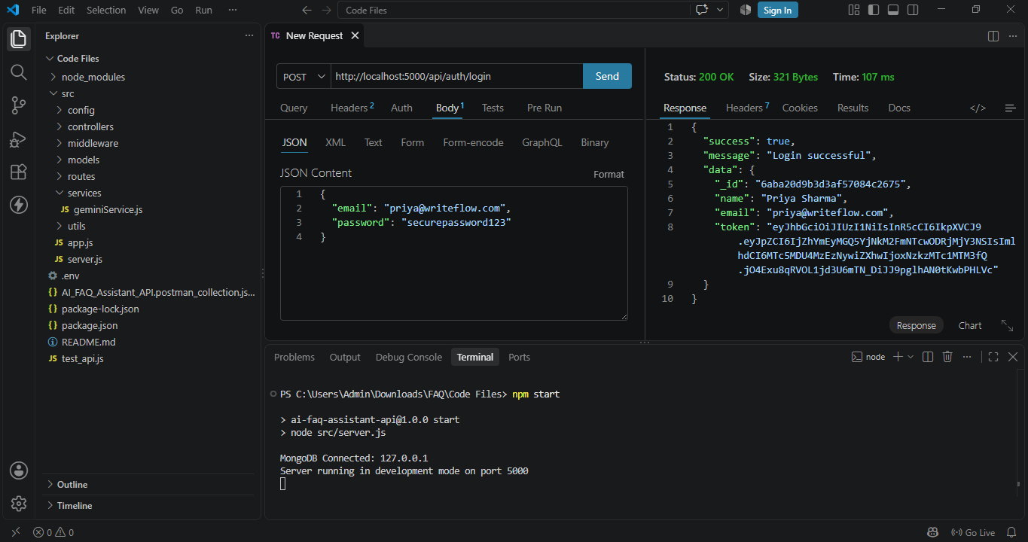

- CREATE FAQ API RESPONSE
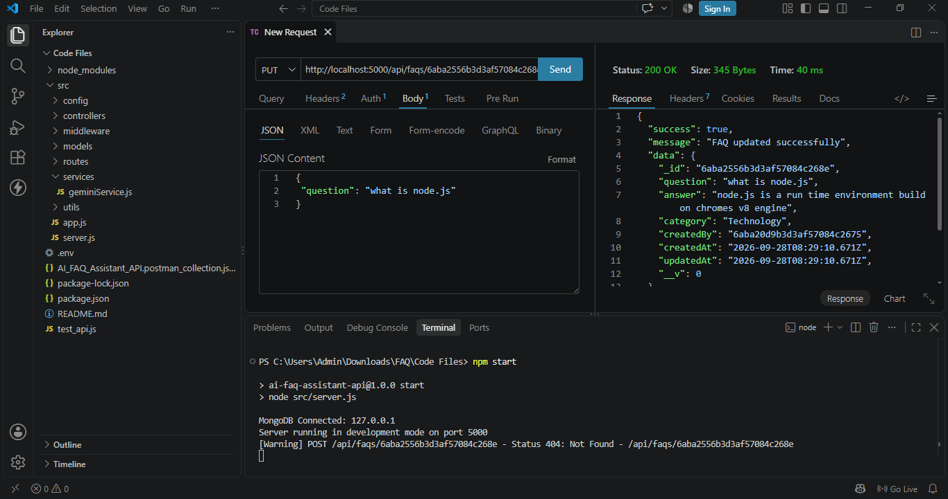
- FAQ SEARCH RESPONSE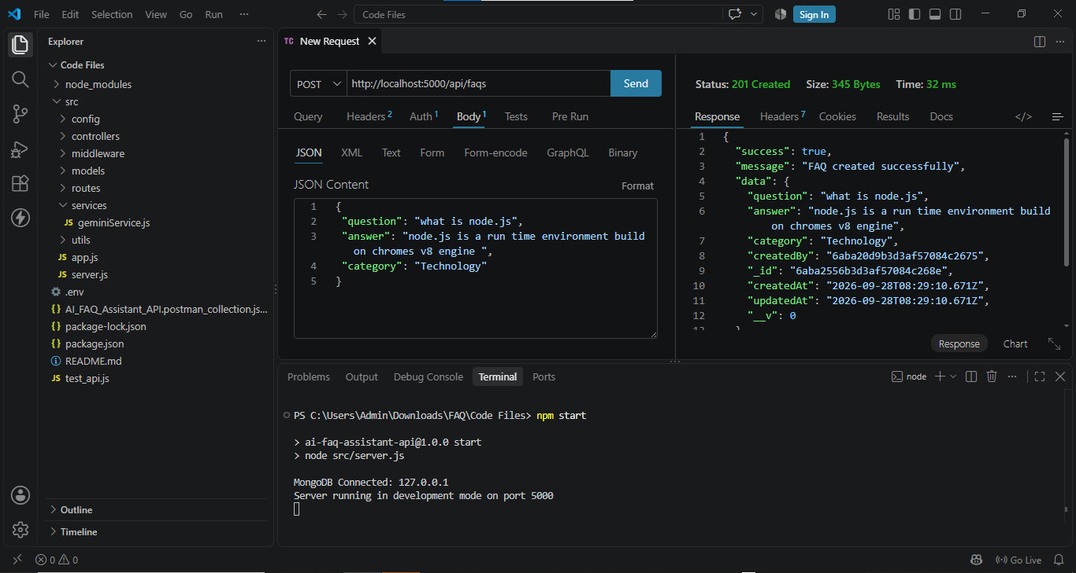

- AI FAQ GENERATION RESPONSE
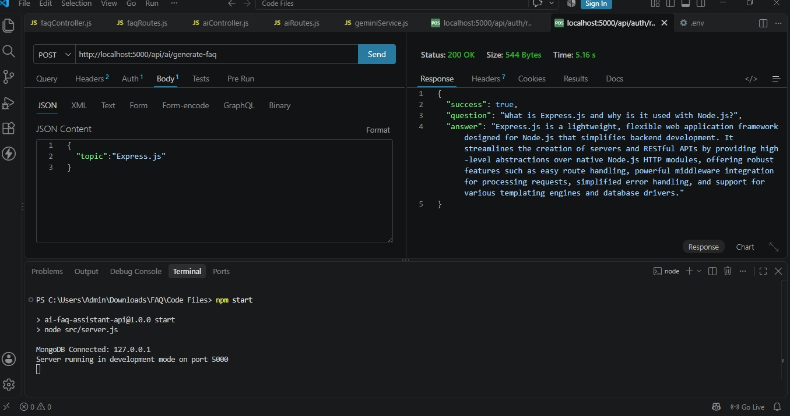

18. Conclusion
AnswerBot provides a centralized backend for FAQ management, authentication, search, CRUD operations and AI-assisted FAQ generation. The documented architecture uses Express.js, MongoDB/Mongoose, JWT, bcrypt and Google Gemini to support the core workflow.
19. Demo Video
https://drive.google.com/file/d/1oEOpipCVLQGRMpF4MsBxvZnOWKiVFuYQ/view?usp=drive_link

